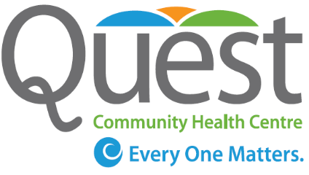

Board Governance Manual
Quest Community Health Centre

Approved by:

Quest Community Health Centre Board of Directors
Approved: 02.28.09
Revised: 05.16.2013 – Approved:10.17.13
Revised: 06.18.15 - Approved: 09.27.15
Revised: 06.23.16 - Approved: 09.28.17
Next Review Date:


The report has been formatted for viewing electronically and for back-to-back printing

Quest Community Health Centre
145 Queenston St.
Suite 100
St. Catharines, ON
L2R 2Z9
Web Site: http: www.questchc.ca
Phone: 905.688.2558
Fax: 905.688.4678

Table of Contents
Board Member List 7
Board Calendar 7
Accountability Framework 10
Letters Patent 11
Supplementary Letters Patent 15

Board Member List
- Rick Kennedy (Chair)
- Gail Riihimaki (Vice Chair)
- Blair Hutchings (Treasurer/Secretary)
- Janice Arnoldi
- Anne Marie DiSanto
- Mary Jane Johnson
- Carol Nagy
- Jennifer Tsang
- Jon Watson
- David Veres
- Francesca Vergalito

Board Calendar
Board Calendar to be inserted once approved (Governance Committee and Board)

Accountability Framework

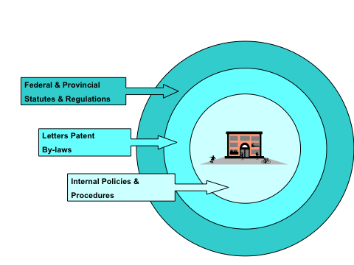

Like all corporations (for profit and not-for-profit), Quest Community Health Centre operates within a hierarchy of aligned accountability systems.
At the broadest level, Quest must comply with Federal and Provincial Statutes and Regulations. The federal and provincial legislation governing corporations including remittances that must be filed by corporation as employers are one type of relevant legislation. Ontario’s legislation governing regulated health disciplines, occupational health and safety and labour standards are other examples.
Quest’s Letters Patent and Bylaws must be consistent with legislation. Similarly Quest’s own internal policies and procedures must be aligned with the organization’s Letters Patent and Bylaws (and by extension relevant legislation).

Letters Patent

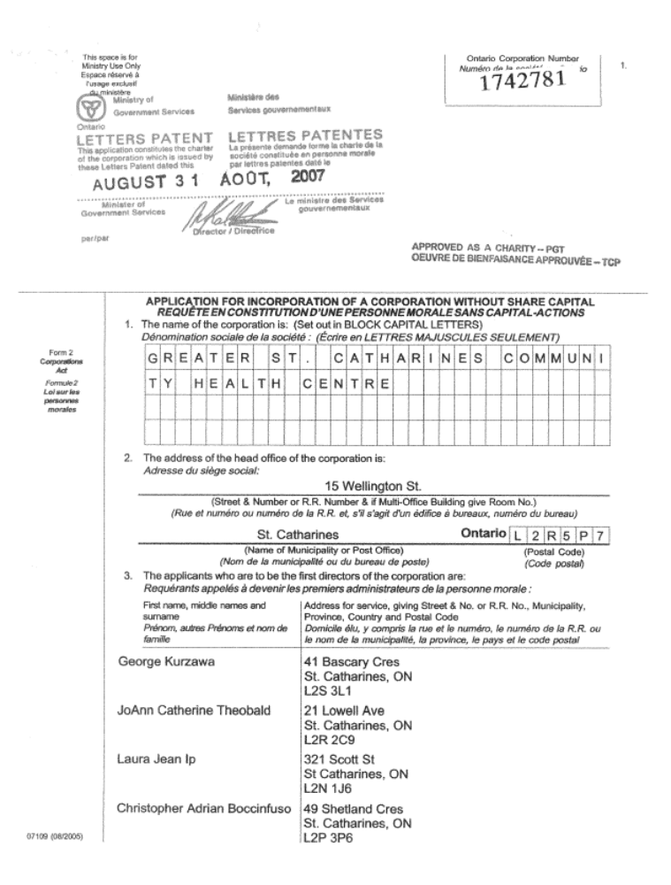

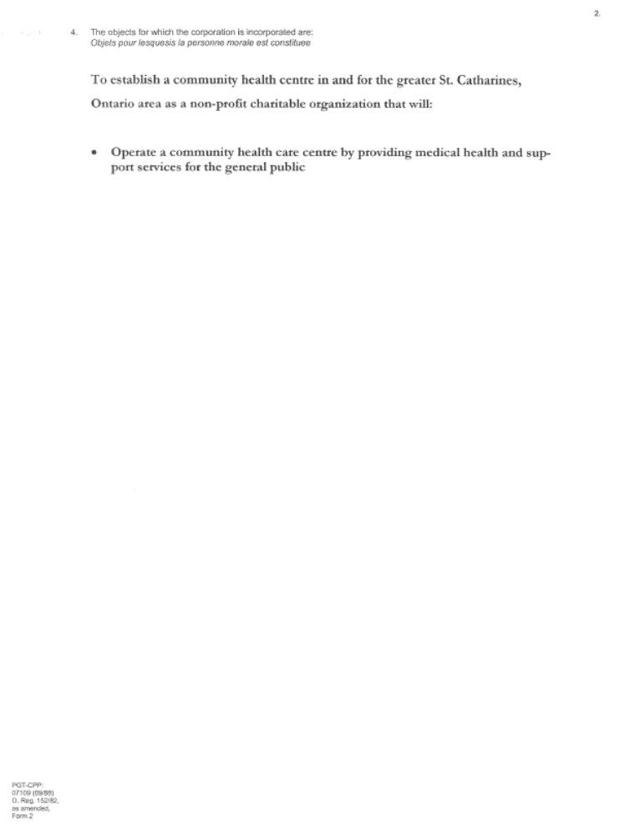

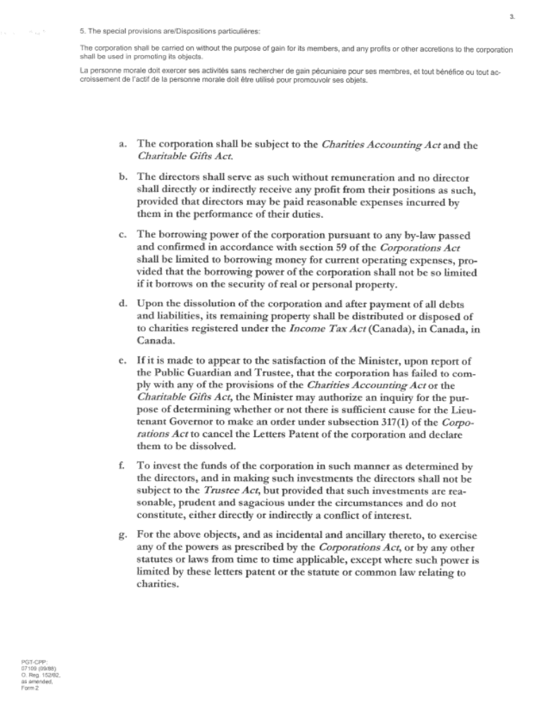

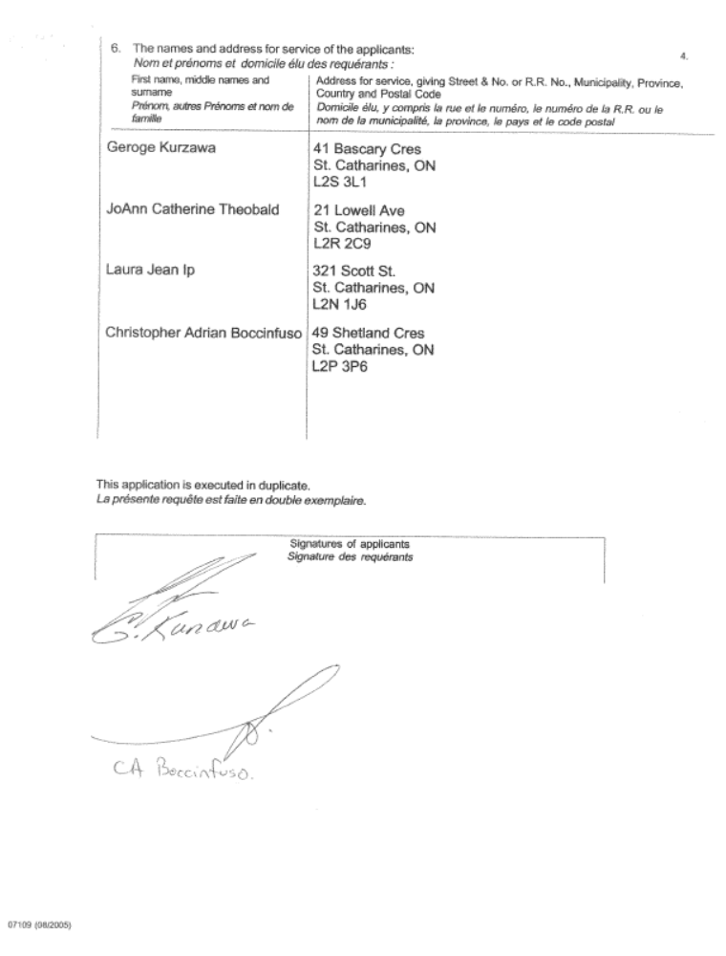

Supplementary Letters Patent



